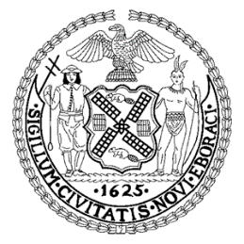
University Neighborhood High School 200 Monroe Street, New York, NY 10003
A New York University Partnership
Elizabeth Collins, Principal Kelly Powel, Assistant Principal Roman Usatin, Assistant Principal

January 31, 2018

Dear Parent(s)/Guardian(s),

The NYC Department of Education is celebrating Career Awareness Month this February and we at UNHS have some exciting programs planned for our students. There will be programing throughout the month to help students learn what career path is right for them. We will also host resume and interview workshops to prepare them for future summer internships and jobs.

On Tuesday, February 13, we would like to invite you to our school to be a part of a career panel! This exciting event will allow students to hear directly from people working in various industries to learn more about these career paths. If you are interested, please fill out the below form and have your child return it to school by Tuesday February 6th.

The NYCDOE’s Office of Postsecondary Readiness is hosting their 2nd Annual Summer Enrichment Program Fair on Saturday February 17, 2018 for grades 9-12. At the fair students and families will learn about summer activities, programs and paid job opportunities. This will be held at the New York Public Library, Stephen A. Schwarzman Building 475 Fifth Avenue (42nd St and Fifth Ave.) from 12pm-5pm. They recommending registering by February 9, but it not required. Please go to http://bit.ly/2DBH4ne to register and see the list of companies that participated last year.

Sincerely,

Ms. Elizabeth Collins
Principal

UNHS Career Panel – Tuesday February 13, 2018
PLEASE PRINT

_______ YES, I would like to participate in the career panel discussion.

My occupation is__________________________________ My title________________________

What are your responsibilities? ______________________________________________________
_______________________________________________________________________________

_______ YES, you may list my employer’s name.
Employeer _______________________________________________________________________

Your child’s name:___________________________________________ Grade:_________________________

Your name:________________________________________________________________________________

Your contact information: Phone___________________E-mail______________________________________

Thank you for helping to educate our students about your career.

Return this form to Ms. Constantinou in room 406 by Tuesday February 6, 2018

